**CASCADING STYLE SHEET (CSS)**

**Inserting CSS:  
1. Inline CSS:** <html>

<head>=

<title>Inline CSS</title>

</head>

<body>

<h1 style="color: Lime; text-align: center;">This is the header</h1>

<p style="font: bold; color : tomato;">This is the paragraph</p>

</body>

</html>

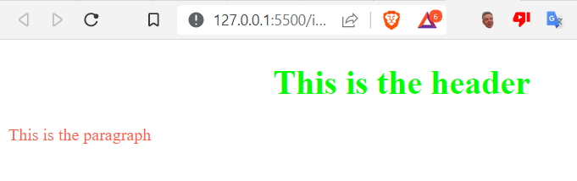

**2. Internal CSS:** <html>

<head>

<title>Document</title>

<style>

h1{

color: magenta;

text-align: justify;

}

p{color:#00ff22;}

</style>

</head>

<body>

<h1>This is a header</h1>

<p> This is a paragraph</p>

</body>

</html>

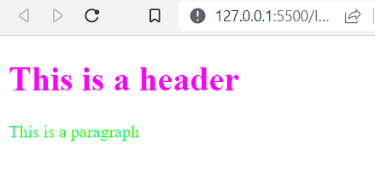

**3. External CSS:**

<html>

<head>

<title>External CSS</title>

<link rel="stylesheet" type="text/css" href="mystyle.css">

</head>

<body>

<h1> Welcome to the external CSS</h1>

<p>This is how you implement the external css</p>

</body></html>

**mystyle.css:**

body{

background-color: red;

}

h1{color: deepskyblue;

text-align: center;}

p1{ color: darkblue;size: 20px;}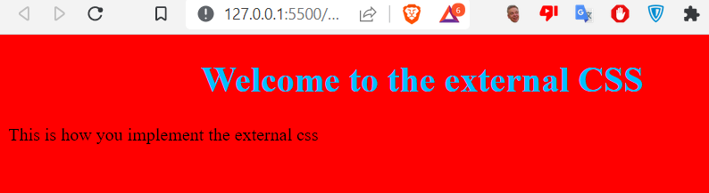

**Class id and class selector:**

**1. The CSS element selector:**

p{

text-align: center;

color: red;}

**2. The CSS id selector:**

#para1{

text-align: Right;

color: rebeccapurple;

font-size: larger;}

**3. The CSS class selector:** .main{

text-align: center;

font-size: 30px;

color: green;}

**4. The CSS Universal selector:**

*{

text-align: center;

color: red;}

**5. The CSS Grouping Selector:**

p,.main,#para1{

color: blue;

text-size: 30px;}

Example:

<html>

<head>

<title>class Id and class selector</title>

<link rel="stylesheet" href="elementselector.css">

<link rel="stylesheet" href="id selector.css">

<link rel="stylesheet" href="classselector.css">

<!-- <link rel="stylesheet" href="universalselector.css"> --> <!--THIS IS THE UNIVERSAL SELECTOR-->

</head>

<body>

<p>This is the element selector</p><!--THIS IS THE ELEMENT SELECTOR-->

<p id="para1">This is the CSS id selector</p><!--THIS IS THE ID SELECTOR-->

<p class="main">THIS IS THE CSS CLASS SELECTOR</p><!--THIS IS THE CLASS SELECTOR-->

</body>

</html>

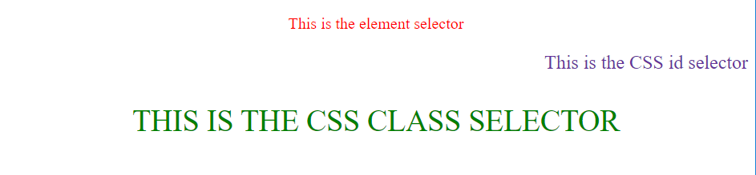

**CSS Borders:**

p{

border: 2px inset rgb(52, 1, 254);

/* CSS text */

color: gray;

text-align: center;

text-decoration: none;

text-transform: inherit;

word-spacing: 3px;

text-shadow: 2px;

} // cssborder.css

**HTML doc:**

<html>

<head>

<title>Border text</title>

</head>

<link rel="stylesheet" href="cssborder.css">

<body>

<header>

<h1> This is where we learn to insert border from CSS</h1>

</header>

<p> Lorem ipsum, dolor sit amet consectetur adipisicing elit. Iste tempore quibusdam nostrum autem. Ullam.</p>

</body></html>

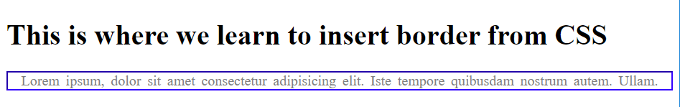

**CSS LIST:**

CSS file:

p {size: 16px ; color: blue;

}

ul {

list-style: disc;} // csslist.css

HTML file:

<html>

<head>

<title>List using CSS</title>

<link rel="stylesheet" href="csslist.css">

</head><body>

<b><p> What should i do next?</p></b>

<ul>

<li>Study</li>

<li>Have a strong vision</li>

<li>Focus on my career</li>

<li>Should not waste my time</li>

</ul>

</body></html>  


**CSS Table:** CSS file:

table,th,td{

border:1px inset black;

}

table{

width: 100px;

}

th{height: 50px;}

tr:hover{background-color: yellow;}

tr:nth :nth-child(even){background-color:#f2f2;}

th{

background-color: #55ff00;

color:Blue;

}

HTML File:

<html>

<head>

<title>Table in CSS</title>

<link rel="stylesheet" href="csstable.css">

</head>

<body>

<header><h2>TABLE IN CSS</h2></header>

<section>

<div>

<table>

<tr>

<th>S.N</th>

<th>Name</th>

<th>Address</th>

</tr>

<tr>

<td>1</td>

<td>Saini</td>

<td>Bhaktapur</td>

</tr>

<tr>

<td>2</td>

<td>Sushil</td>

<td>Dang</td>

</tr>

</table>

</div>

</section>

</body></html>

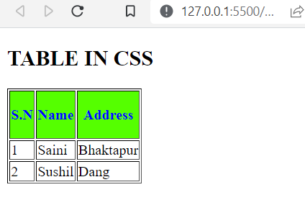

**CSS Box:**

CSS file:  
 div{

background-color: peachpuff;

width: 300px;

border:1px solid black;

padding:50px 30px 50px 30px;

text-align: center;

margin:100px 0px 0px 0px;

position: relative;}

HTML file:

<html>

<head>

<title>Box model</title>

<link rel="stylesheet" href="cssbox.css">

</head>

<body>

<div>This is normal layout</div>

<div>Another padded text</div>

<div >We check whether the text is on its relative position</div>

<div>Lorem ipsum dolor sit amet</div>

</body>

</html>

